Setting up of Stage Plan for Innsbruk to Munich:

**Login to City Admin** (username: [cityadmin@dummy.com](mailto:cityadmin@dummy.com), password: cityadmin)**:**

* + Select School: Garmish_School_Dummy
  + Select Class:Class 1A
  + Set Range of Stage Plan for Innsbruk:
  + Select Radius: 101km to 200km
  + Select to City: Munich

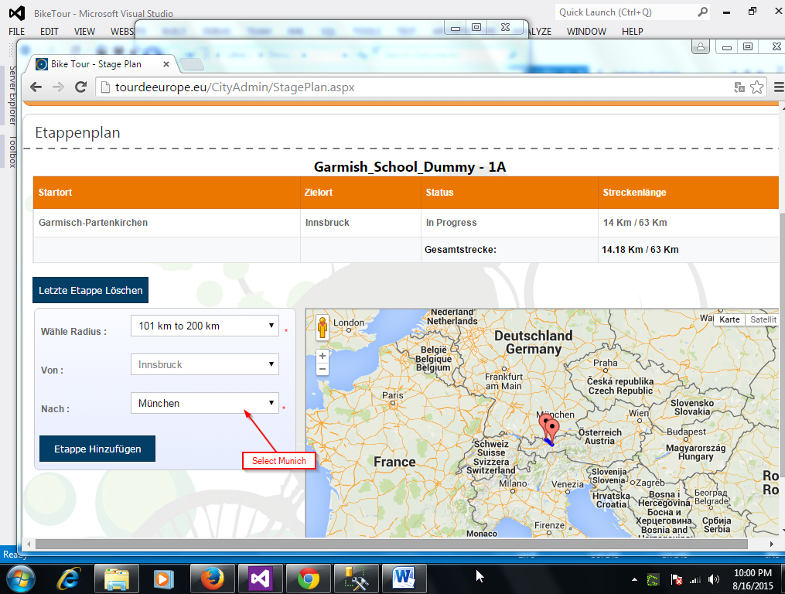

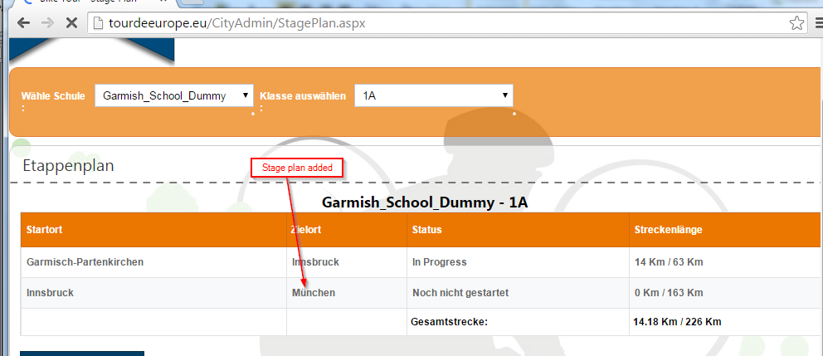

Log out

**Login dummy Student** (username: dummyStudent, password: dummystudent)**:**

It reflects the current stage, if needed it shows to peform quiz, and in the bottom it shows a table all stages

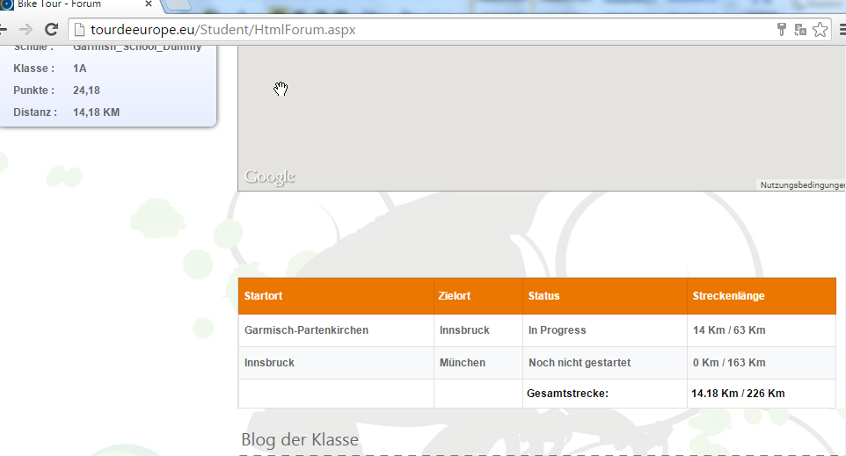

Uplaod Gpx:

Student needs to upload .gpx to reach from Garmisch the next city, Innsbruk

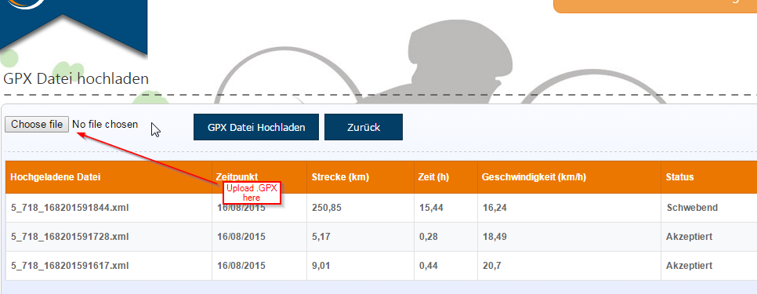

Since I do not have valid .gpx fils to upload, so I updated the records in the DB and tested

Upton login again, I saw the next stage for Innsbruk, with a Quiz

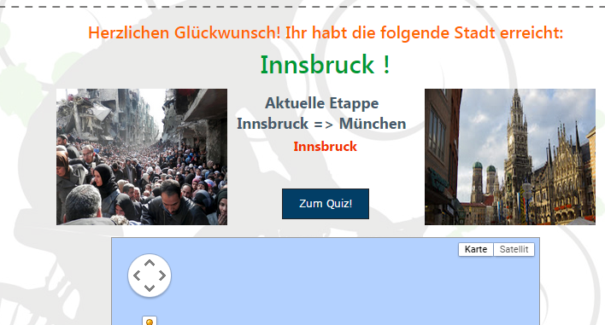

Appear Quiz:

